Hkkjrh; izkS|ksfxdh LkaLFkku iVuk
Indian Institute of Technology Patna
Dept. of Electrical Engineering
IIT Patna Campus, Bihta, Patna, Bihar – 801103 Experiment No.- 8

Generation of TTL level Signals

OBJECTIVE: Generation of TTL level signals from small amplitude sinusoidal signals.

COMPONENTS REQUIRED
: Op-Amp : One LM741
: Transistor : One 2N2222A
: Diode : One Diode
: Resistance: One 330 Ohm, four 1K Ohm, Three 10 K Ohm, Two 100 K Ohm.
: ICs : One 74LS00 (NAND gate), one 74LS93 (4-bit binary counter).
PRECAUTIONS AND GUIDELINES

1. The op-amp generally works on split power supply (e.g. ±12 V). Both positive and negative power supplies must be present whenever op-amp is powered. The range of power supply is from ±5 V to ±15 V. Do not forget to connect the common terminal of the power supply to the ground on the breadboard.
2. Connecting only one side of power supply or interchanging positive and negative power supplies damages the op-amp.

3. While switching on the set-up, switch on the oscilloscope first, then the power supply to the circuit, and finally the function generator. When switching off, follow the sequence in reverse order.
4. For any IC, never exceed the input voltage beyond the power supply limits.

5. Keep ground terminals of the oscilloscope probes and function generator output, and power supply common connected together throughout the experiment.
The circuit shown in Fig. 8.1 is for obtaining a TTL level signal and feeding it to a counter.
Working Principle:
The TTL NAND gate 7400 is driven by the transistor. When the transistor is in saturated state, its collector is about at 0.2V and it is a low level signal for the TTL gate (the TTL gate can drain out necessary 1.6 mA current through the transistor). The transistor will be in ‘ON’ state when the variable amplitude sinusoidal signal fed at ‘+’ terminal of the op-amp is greater than the reference DC level obtained through the potential-divider configuration. The TTL level output of the NAND gate (clock) is fed to the counter 7493. Please see the internal logic diagram for 7493 in Fig 8.2. Please note that, since the mod-16 counter is consisted of a mod-2 counter plus a mod-8 counter, to have a decade or mod-16 counter ‘QA’ has to be connected to ‘CLKB’.

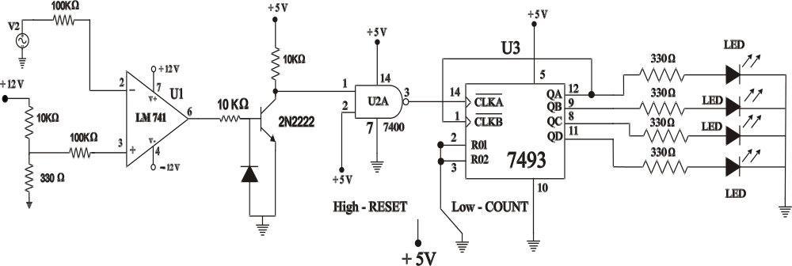

Fig. 8.1: Obtaining a TTL level signal and feeding it to a counter.

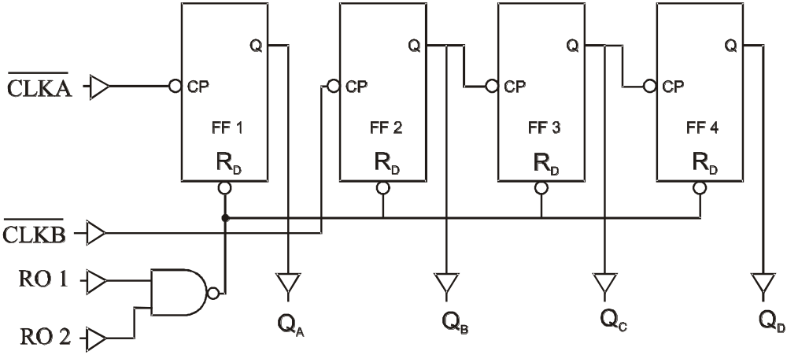

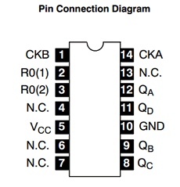
Fig. 8.2: Internal logic diagram of 74LS93 counter

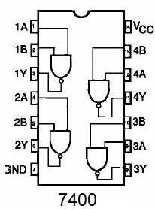
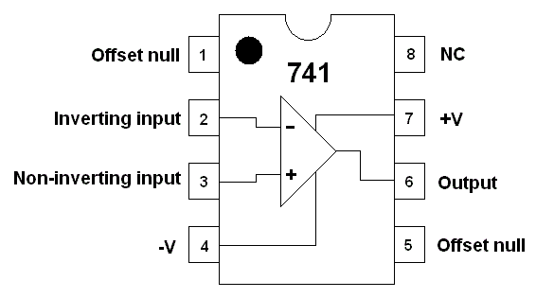

LM741 74LS93

Fig. 8.3: Pin diagram of LM741 Op-Amp, 74LS00 NAND gate & 74LS93 counter

OBSERVATIONS:
Mod-16 counter:

1. Connect the circuit as shown in Fig. 8.1 with ‘CLKB’ connected to ‘QA’. Make sure the power supply ground is connected to the circuit ground.

2. Observe the output of the transistor with respect to the sinusoidal (1Hz, 10Vp-p & High Z Mode in AFG) input signal.

3. Observe the blinking of the LEDs in a proper sequence. To do this you have to use very low input frequency.

4. Disconnect pin ‘1’ of the 74LS00 NAND gate from the transistor output. Now, try to give a single pulse to the NAND gate (input pin ‘1’) by momentarily touching the input wire to 0V (ground). You will expect the count value will increase by one.

Please note that: It may be very difficult to obtain a single pulse by this hand touching method. We shall find a way to accomplish this in our next lab experiment.

Q. Determine the minimum Peak to Peak Input Sinusoidal Voltage to get TTL Level Signal.

-------------------------

